ENGLISH – GRADE 9
PERIOD 54
Full name: ...............................................  Class: ...................................................... | THE FIRST-SEMESTER TEST  Time: 45 minutes
I. LISTENING (2.5pts)
1. Listen to a conversation between Long and his mother about her school days. Fill each of the gaps in the notes with NO MORE THAN THREE words and/or a number. You will listen TWICE. (1.25pts)
Mum's School Time
- In school (1) from __________ to _________
- School: close to a (2) ______________; one-story building; large yard
- Subjects: no (3) _______________ class; started learning English in Grade 6
- Meals: no (4) _______________ at school
- After school: not much (5) _______________; did housework to help family
2. Listen to a conversation between two friends about a neighbourhood. Fill each of the gaps with ONE word. You will listen TWICE. (1.25pts)
Jollyland is a (1) ______ neighbourhood in the heart of the city. The streets are picturesque, full of (2) ______ old shops in gorgeous buildings. As there’s so much to do within (3) ______ distance, you won’t need to use a car very often. There’s the usual variety of bars, restaurants, (4) ______ and so on that you’d expect in a city. For families, there are great parks, an excellent (5) ______ library and good schools close by. In Jollyland, there’s a real sense of (6) ______. The locals, a mix of original residents and new arrivals, say it’s almost like living in a village.
II. READING (2.5pts)
1. Read the following passage and answer the questions. Circle A, B or C. (1.25pts)
Promotion of learning and respect for teachers are among the traditional values of the Vietnamese people. In the old days, it was commonly believed that a teacher's position was higher than parents' and only lower than the king's. In many communes and villages, rich people invited teachers to stay in their houses to teach their own children and those from other families. To become a mandarin, a candidate had to have excellent learning achievements and gained high marks in competitive exams. The first such exam for civil administrators was conducted in 1075.
For nearly one thousand years, Vietnamese people learnt Chinese characters and used them for writing, but pronounced them in a different, Vietnamese way. Besides the use of Chinese characters, the Vietnamese people adapted such characters to invent an ancient Vietnamese script for writing and expressions. Many valuable works of literature and history were kept for the future generations thanks to the script. This development and preservation strengthened an awareness of national independence and ensured that the Chinese did not assimilate the Vietnamese people.
1. | What is the passage mainly about?
 | A. Educational values of Vietnamese people
 | B. Vietnamese education in the past
 | C. Scripts in Viet Nam's education history
2. | According to the passage, which of the following is NOT true about teachers?
 | A. They were highly respected in the society.
 | B. They used to live in the students' homes.
 | C. They would become civil administrators.
3. | What can the word "conducted" be best replaced by?
 | A. organized
 | B. managed
 | C. taken
4. | What does the word "them" in paragraph two refer to?
 | A. years
 | B. people
 | C. characters
5. | Which of the following is said about the ancient Vietnamese script?
 | A. Its characters were totally different from the Chinese characters.
 | B. All Vietnamese valuable literary works were written in this script.
 | C. It promoted a sense of national independence among Vietnamese.
2. Match each statement (1. 5) to one the sign/notice (A - F). There is one extra sign/notice you do not need to use. Write the letters in the space provided at the end of each statement. (1.25pts)

A. |  | 1. You cannot cross the street here. _____  2. You cannot enter. _____  3. Don't walk on the rail lines. _____  4. Slow down. _____  5. Be careful not to hurt your head. _____
B.
C. | 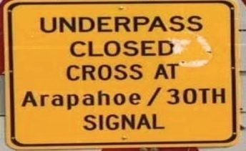
D.
E.
F.

III. WRITING (2.5pts)
1. Write a paragraph (100 - 120 words) about the recent changes in your neighborhood or city. (1.25pts)
You should write about:
- The changes
- Things that caused them
- The effects of the changes on you
______________________________________________________________________________
______________________________________________________________________________
______________________________________________________________________________
______________________________________________________________________________
______________________________________________________________________________
______________________________________________________________________________
______________________________________________________________________________
______________________________________________________________________________
______________________________________________________________________________
______________________________________________________________________________
______________________________________________________________________________
______________________________________________________________________________
______________________________________________________________________________
______________________________________________________________________________

2. Complete each of the following sentences using the cues given. You can use other words in addition to the cues to complete the sentences. (1.25pts)
Here is an example.
0. Ngoc/usually/play/badminton/Sunday.
Answer: 0. Ngoc usually plays badminton on Sundays.
1. People/know/Ha Long Bay/recognise/UNESCO.
__________________________________________
2. Temple of Literature/be/first/destination/schedule.
__________________________________________
3. They/think/visit/Mai Chau/this/time/year/be/best.
__________________________________________
4. People/believe/visit/Huong Pagoda/bring/luck.
__________________________________________
5. People/believe/Phong Nha/be/biggest/cave/Viet Nam.
__________________________________________

IV. SPEAKING (2.5pts)
1. Now I’m going to ask you FOUR questions about your friends. Are you ready? (1.25pts)
1. | What is your favourite place of interest in your town/city?
2. | Who do you want to go there with?
3. | What can you do there?
4. | Why do you like it?
2. Each of you will now receive a pair of cards. On one card there is a short notice and on the other card there are clues for five questions. You should use the clues to make questions and ask your friend. Your friend will answer the questions based on the notice he/she has. Here are your cards. You will have 30 seconds to prepare. You can make notes on the paper. (1.25pts)
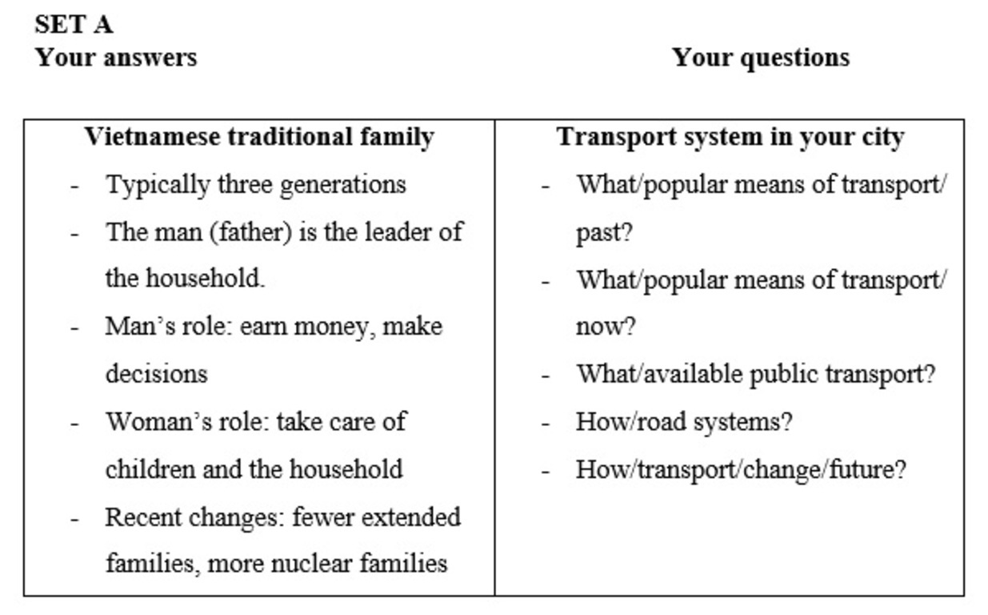
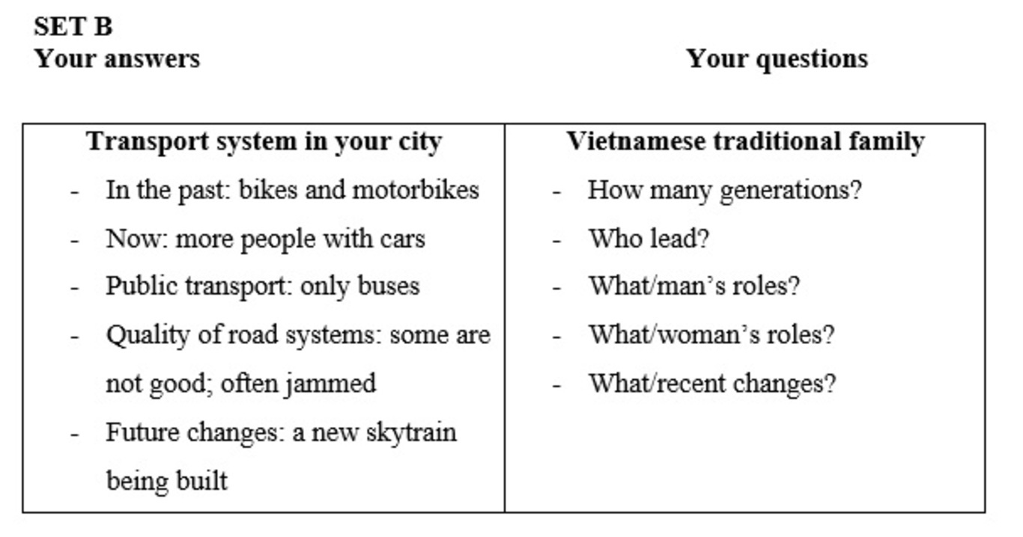
-- The end --
CORRECTION – THE FIRST-SEMESTER TEST
I. LISTENING (2.5pts)
1. Listen to a conversation between Long and his mother about her school days. Fill each of the gaps in the notes with NO MORE THAN THREE words and/or a number. You will listen TWICE. (1.25pts)
- from 1980 to 1992
- paddy field
- computer (skills)
- lunch
- homework
2. Listen to a conversation between two friends about a neighbourhood. Fill each of the gaps with ONE word. You will listen TWICE. (1.25pts)
1. historic 2. fascinating 3. walking 4. gyms 5. public 6. community
II. READING (2.5pts)
1. Read the following passage and answer the questions. Circle A, B or C. (1.25pts)
1. B 2. C 3. A 4. C 5. C
2. Match each statement (1. 5) to one the sign/notice (A - F). There is one extra sign/notice you do not need to use. Write the letters in the space provided at the end of each statement. (1.25pts)
1. C 2. D 3. F 4. B 5. A
III. WRITING (2.5pts)
1. Write a paragraph (100 - 120 words) about the recent changes in your neighborhood or city. (1.25pts)
Sample writing:
There have been several changes in my neighborhood. It has got much more crowded in recent years. More and more people have been moving here to work. Therefore, the traffic has become busier and there are often traffic jams during rush hours. Also, more high buildings have been built to meet the demand for accommodation. However, there is less green space in my neighborhood now. It also has gotten noisier. These changes have influenced my life greatly. Now it takes more time for me to get to school, and I don’t have anywhere to go for some fresh air after school. I also don’t sleep very well because of all the noise. The smoke from all the traffic and factories pollutes the air and makes travelling during rush hours terrible.
2. Complete each of the following sentences using the cues given. You can use other words in addition to the cues to complete the sentences. (1.25pts)
1. People know that Ha Long Bay is recognised by UNESCO.
2. Temple of Literature is the first destination in my schedule.
3. They think that visiting Mai Chau at this time of the year is the best.
4. People believe that visiting Huong Pagoda will bring them luck.
5. People believe that Phong Nha is the biggest cave in Viet Nam.
IV. SPEAKING (2.5pts)

